Austin Osborn
COMP 2710-001
Lab 3 Design Portion
Aeo0015@auburn.edu

Analysis (Use Cases)

- Initial execution: The user is prompted to enter the number of players. Then prompted line by line to enter their names.
- Dice Roll: With all of the initial setup out of the way. The gameplay will ask the user to roll the dice.
  - Simply pressing enter will count as the roll.
- Choosing where to go: The user will be entitled to go to as many nodes as their nice roll gives them.
  - If their current position node has a snake/ladder. User is forced to go to where it points
  - Otherwise, the user will be greeted with choices (up to 4), and prompted appropriately to input whichever direction they want to go (either South(s), North(n), East(e), or West(w))
- Victory!: A player’s current position is the destination node. This means that player has won!
  - System will print out a congratulations message and display the list of nodes they took to get to the finish.
  - Execution ends.

Class Diagram
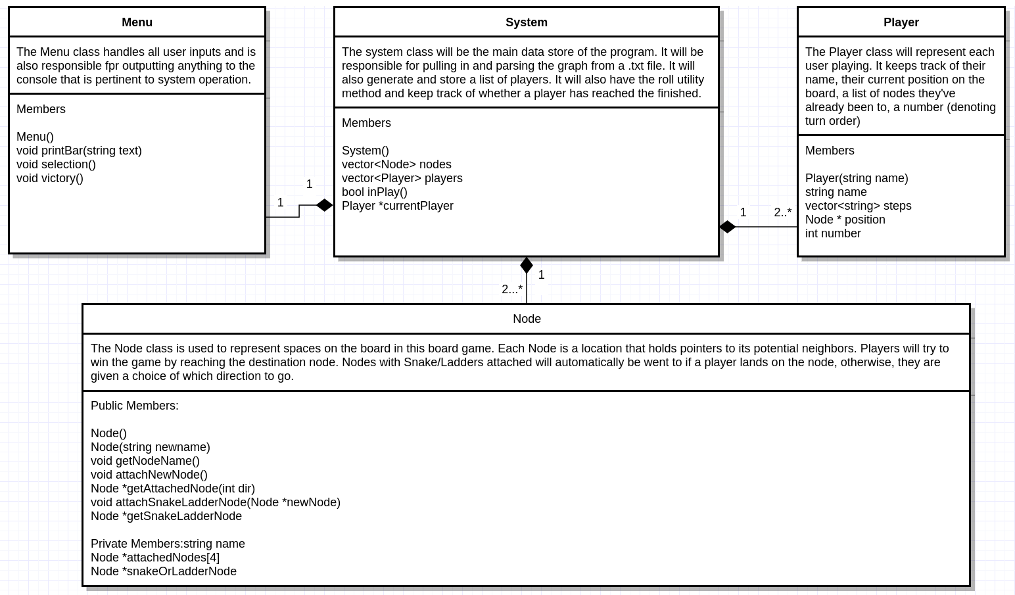

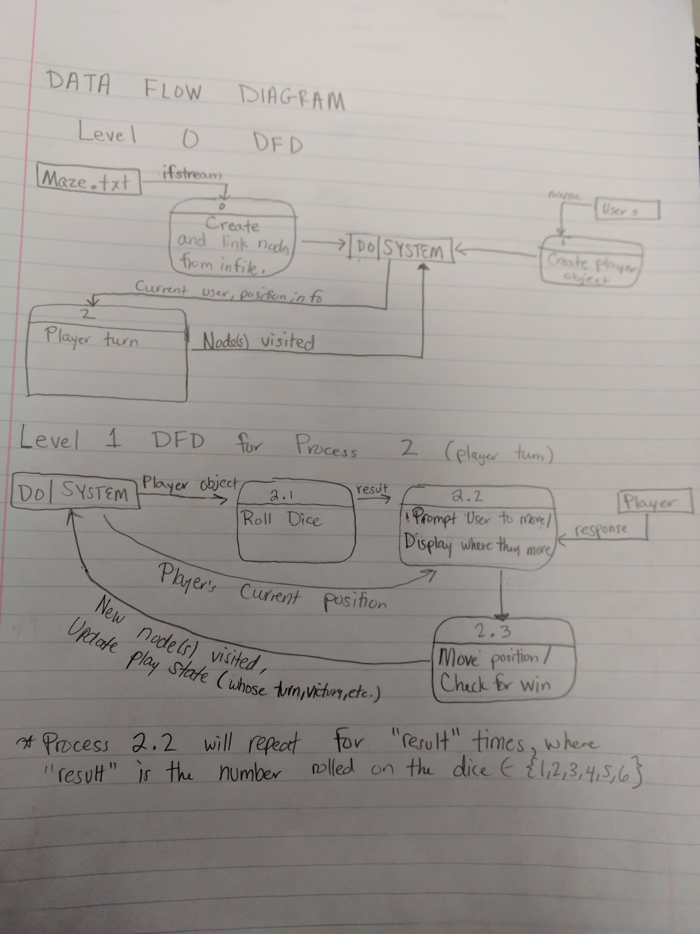
Data Flow Diagrams

Testing (Test Cases)

A. System Wide

- Program is first executed.
  - Input file is read from.
    - Nodes are created and initialized properly, with pointers correctly configured. (Debug looking for System member nodes to ensure this)
  - Prompt for number of users
    - Reject any input that isn’t a integer number.
  - Prompt for names until number of users is met.
    - Create new player objects, note their order (the order determines who goes 1st, 2nd, 3rd, etc.). (Debug looking for System member players to ensure this takes place)
  - Begin player
    - Program should prompt user for dice roll and subsequent choices on where to go.
B. Specific Objects/Functions

- User rolls a dice
  - “Enter” is pressed as a “dice roll”
  - The system returns a number between one and six, the number of moves the player gets that turn.
    - This number is random (I,e ensure new time seed being called each run)
  - That player is given that number of turns in a row.
- User reaches end Node
  - System immediately notices this and stops allowing any input.
  - System gives congratulations message to the winner, displaying their name, number of moves, and list of all nodes visited on their journey.
- Player lands on any non-end Node
  - If the node has a snake/ladder, user is transported to wherever the snake/ladder points to. No choose is given.
  - Otherwise, player is printed a list of neighbors and told to choose which direction they want to go
    - I.e: If a node has a north, south, and east neighbor, the user is told to choose of these
  - If a valid choice is made, that Player’s currentNode becomes the destination of their choice and play continues.
    - Otherwise, menu catches this and re-prompts for valid input direction.
  - Game ends if the node reached is the end Node and (2) happens.
- Player runs out of moves. (Next turn)
  - This means it is the next player’s turn.
    - This next player is set to the System’s activePlayer and they are prompted to roll the dice and follow the processes above.
    - The next player is chosen in the order they were input.
      - I.e) Imagine there are 3 players. The third player enter will go third, sixth, ninth, etc...

